Our Mission:  To support research and educational programs related to Ophthalmology and vision science in the United States and abroad.  To offer grants to individuals and organization in support of research projects and training programs that advance the understanding of vision and lead to improved treatment of vision related diseases  Daniel F. Rosberger, M.D., Ph.D., M.P.H  President | Foundation for Ophthalmology  Research & Education-International  52 East 72nd Street, NY 10021 |  | Foundation for  Ophthalmology  Research and  Education-  International  (FORE-I)  - Supporting research and education in vision science  - Information about donating and applying for funding

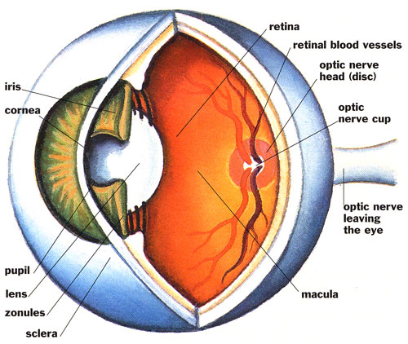  To Donate:  Please make checks payable to Foundation for Ophthalmology Research and Education and send to:  FORE-I  52 East 72nd Street  New York, NY 10021  Alternatively, donations can be made on our website, www.FORE-I.org  FORE-I is a not-for-profit organization organized under the federal IRS 501(c)(3) statute. All donations are tax deductible. | Small Grants with Big Impact  FORE-I seeks to fund novel, game-changing, high impact pilot and proof of concept research from junior faculty at research centers in the United States and around the world.  To apply for grant support:  Download the grant application on www.FORE-I.org and return in PDF format to DRosberger@FORE-I.org  For questions and additional information:  Foundation for Ophthalmology  Research & Education-International  52 East 72nd Street, NY 10021  212-439-9600  DRosberger@FORE-I.org  www.FORE-I.org | 2016 FORE-I Grants awarded:  Cornell University  Eric C. Ledbetter, DVM, DACVO: Evaluation of raltegravir therapy in experimental ocular feline herpesvirus-1 infection  Harvard University-Massachusetts Eye and Ear Infirmary  Magali Saint-Geniez, Ph.D.: Novel gene therapy approach for the treatment of dry AMD  Massachusetts Institute of Technology  Santani Teng, Ph.D.: Hearing the scene: Behavioral and neuroscientific evaluation of assisted echolocation  Princeton University  Sabine Kastner, M.D., Ph.D.: Neural correlates of limited processing capacity in the developing human visual system  Yale University  Bo Chen, Ph.D.: Regeneration of rod photoreceptors by reprogramming Muller glial cells

